Experiment 3: write a Python program to solve the Water Jug Problem

Aim
To write a Python program to solve the Water Jug Problem using the Breadth First Search (BFS) algorithm.

Algorithm
- Define the capacities of the two jugs.
- Start from the initial state (0,0).
- Generate all possible next states by:
  - Filling either jug.
  - Emptying either jug.
  - Pouring water from one jug to the other.
- Mark visited states to avoid repetition.
- Repeat until the required amount of water is obtained.
- Display the sequence of states.

Program
from collections import deque

def water_jug(jug1, jug2, target):

visited = set()
queue = deque()

queue.append((0, 0))

while queue:
x, y = queue.popleft()

if (x, y) in visited:
continue

visited.add((x, y))

print((x, y))

if x == target or y == target:
print("Target Reached")
return

next_states = [
(jug1, y), # Fill Jug1
(x, jug2), # Fill Jug2
(0, y), # Empty Jug1
(x, 0), # Empty Jug2
(max(0, x-(jug2-y)), min(jug2, x+y)),
(min(jug1, x+y), max(0, y-(jug1-x)))
]

for state in next_states:
if state not in visited:
queue.append(state)

water_jug(4, 3, 2)

Output
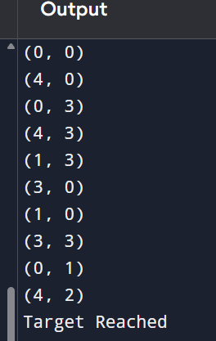

Result
Thus, the Python program to solve the Water Jug Problem using the Breadth First Search (BFS) algorithm was implemented successfully, and the target amount of water was obtained.

